**ST. XAVIER’S COLLEGE**

**(Affiliated to Tribhuvan University)**

Maitighar, Kathmandu



**DATABASE MANAGEMENT SYSTEM**

**THEORY ASSIGNMENT #05**

**Submitted by:**

Rojesh Tamrakar

013BSCCSIT032

**Submitted to:**

|  |  |
| --- | --- |
| **Er. Sanjay Kumar Yadav** |  |

Lecturer

Department of Computer Science

Date of submission: 27th August, 2015

Entity Relationship model

1. What do you mean by Entity-Relationship Diagram? Explain

An entity relationship diagram (ERD) shows the relationships of entity sets stored in a database. An entity in this context is a component of data. In other words, ER diagrams illustrate the logical structure of databases.

At first glance an entity relationship diagram looks very much like a [flowchart](http://www.smartdraw.com/flowchart/). It is the specialized symbols, and the meanings of those symbols, that make it unique.

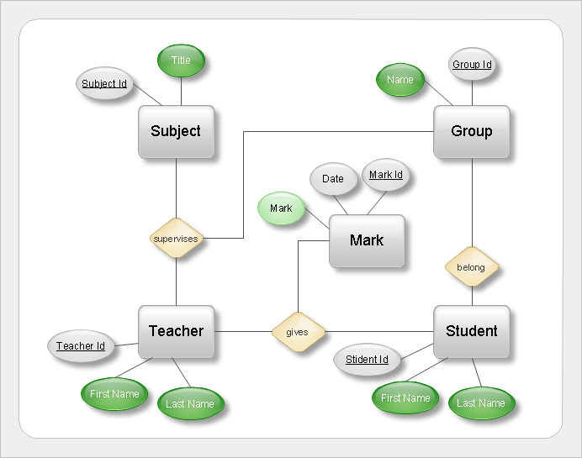

Fig: Entity - Relationship Diagram

1. Define entity and give an example.

An entity is something that exists in itself, actually or potentially, concretely or abstractly, physically or not. It need not be of material existence. In particular, abstractions and legal fictions are usually regarded as entities. In general, there is also no presumption that an entity is animate.

Eg: teachers, students, course etc are entity of a college.

1. Explain the different between an entity class and an entity instance.

**Entity class:** An entity class is a description of the structure and format of the occurrences of the entity. An entity is a person, place, event, or thing about which data is collected.

**Entity instance:** An entity instance of a specific occurrence of an entity class.

1. Define attribute and its types.

Attributes are descriptive properties possessed by each member of an entity set. The designation of an attribute for an entity set expresses that the database stores similar information concerning each entity in the entity set; however, each entity may have its own value for each attribute. An entity is represented by a set of attributes. Possible attributes of the employee entity set are ID, name, dept name, and salary.

It’s types are:

• Simple and Composite Attributes

• Single-Valued and Multi-Valued Attributes

• Stored and Derived Attributes

1. What is derived attributes?

If an attribute's value can be determined from the values of other attributes, then the attribute is derivable, and is said to be a derived attribute. Derived attributes are shown with a dotted lined oval, see the figure below.

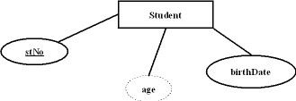

1. Define relationship and give an example.

A relationship is an association among several entities. For example, we can define a relationship n number of student as a member of m teams and a single student as a leader of a single team.

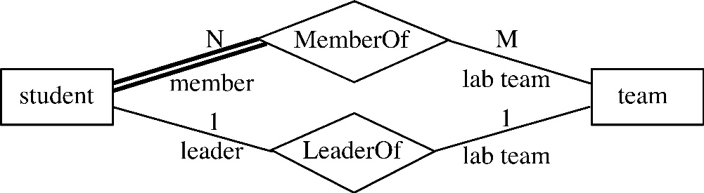

1. Explain the difference between a relationship class and a relationship instance.
2. Define degree of relationship.
3. List and give an example of the three types of binary relationships. Draw an E-R diagram

for each.

1. Define the terms maximum cardinality and minimum cardinality.
2. Explain the distinctions among the terms primary key, candidate key and super key.
3. What are the main building modules of the entity relationship model? Discuss each one.
4. What is composite attributes, when it is used?
5. Explain the difference between single-value attributes and simple attributes.
6. Discuss the difference between a composite key and a composite attribute. How would

each indicated in an E-R diagram?

1. What two courses of action are available to a designer when a multivalued attribute is

encountered?

1. Explain the various terms of an E-R model and how are they represented in an E-R

model?

1. Explain the concept of dependent entities? Give example.
2. What is the difference total and partial participation? Explain.
3. What do you mean by mapping cardinalities? Explain various type of cardinalities.
4. What is the difference between single-value and multivalued attributes? Explain
5. Explain the concept of participation constraints.
6. Difference the binary relationship with ternary relationship with example.
7. Explain the difference between weak and strong entity set.
8. Define the components of extended E-R features.
9. Define the concept of aggregation. Give two examples of where this concept is useful.
10. Explain the distinction between disjoint and overlapping constraints.
11. Explain the distinction between total and partial constraints.
12. Write short notes on:

• Specialization

• Generalization

• Aggregation